Insert your school logo here

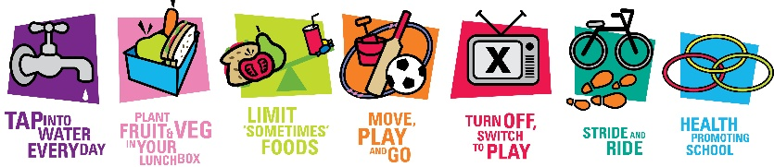

School name Move Well Eat Well Policy
School Staff: Use this policy template to meet the policy requirement for Move Well Eat Well.
- Please note for the criteria with yellow highlights we require examples of how you meet this in practice. If you require help with examples please contact us.
- You may like to further personalise your policy by including other ways your school is meeting each of the criteria.
- You can cut and paste these bullet points into your existing relevant school policies if you prefer.
- Consider adding details of how you involve your school association/parent body and student council in your decision-making.
- To apply for or continue as a Move Well Eat Well Award School, ensure all points are included in your policy(s).
- Delete these blue instructions before submitting your policy.

Aim: To promote the health and wellbeing of students and the whole of school community by making healthy eating and physical activity a regular part of every day.
Rationale: Our school recognises that the whole of school environment can help students develop
healthy habits to live, learn, grow and play.
Relevance: This policy is relevant to staff and families. Our school recognises that this policy underpins
practice. To keep it relevant and current this policy is reviewed every 2 years. Unless
otherwise stated, this policy applies to all students at all year levels.

Healthy Eating

Tap Into Water:
- All students are encouraged to drink water throughout the school day, especially during PE.
- Children can bring ‘water only’ water bottles to class and PE.
- Water bottles can be refilled as needed.
- Children are reminded to drink water throughout the day.
- All classrooms are ‘water only’ zones. Sweet drinks are not permitted during class time.

Plant Fruit and Veg in your Lunchbox:
- All students are encouraged to eat fruit and vegetables while at school.
- Classrooms have a daily fruit and vegetable break.
- Fruit and vegetables are promoted for inclusion in lunchboxes. Please provide examples of how you do this
- Our school encourages healthy eating behaviours in a positive, relaxed and social environment.

Limit ‘Sometimes’ Foods:
- Our school canteen/lunch service/local shop order/lunch days meets a level of accreditation/is working towards a level of accreditation/ has had the menu assessed by the School Food Matters SmartFood Program. Note: If your school offers lunch to students weekly or more frequently, select which options apply to you. If you do not offer lunch to students at all, delete this point.
- Staff are encouraged not to use ‘sometimes’ foods as rewards in class.
- ‘Sometimes’ foods are limited in the wider school environment and the school community is encouraged to limit ‘sometimes’ foods. Please provide examples of how you do this

Physical Activity, Screens and Sitting

Move, Play and Go:
- Two hours of physical education/education is timetabled for all students. Please provide detail of how you meet the 2 hours.
- Free and creative active play is part of the daily curriculum and spread throughout the day in the Early Years.

Turn Off, Switch to Play:
- At break times a system is in place to provide regular access to play equipment that encourages physical activity. Please provide examples of how you do this
- Screen-based activities are predominantly used for educational purposes. Please provide examples of how recreational screen use is limited
- Our school takes measures to break up long periods of sitting.

Stride and Ride:
- All students are encouraged to participate in an age-appropriate activity at least once a term, that promotes safe walking or riding, either to school or other places. Please provide examples of how you do this (swimming, cross country and athletics carnivals do not contribute to stride and ride active transport activities).

Healthy School

Health Promoting School:

Curriculum
- A health and wellbeing curriculum is delivered to all year levels K – 6, which includes explicit teaching about healthy eating and the benefits of physical activity.

Families and Staff
- Our families and new staff are informed about this policy and are provided with regular information to support physical activity and healthy eating.
- The school has a family-friendly approach in the birth to 4 years programs and has a welcoming attitude to breastfeeding.
- Staff are encouraged to model healthy eating and physical activity practices across the whole school environment. Please provide examples of how you do this

School Principal name: __________________________________ Signature: __________________

Date: ______________________

School Association Representative name: _________________________ Signature: __________________

Date: ______________________

