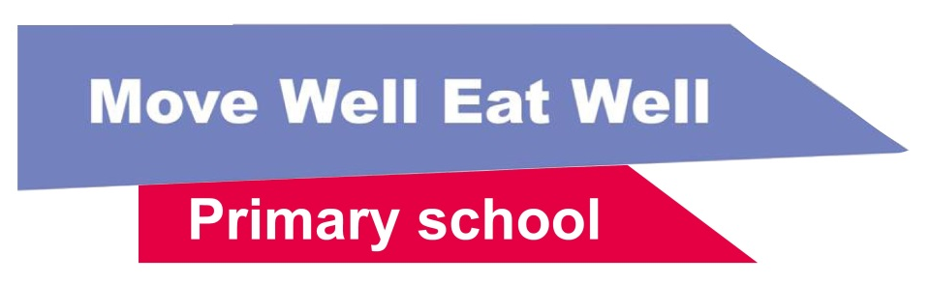 | Calendar 2024  Making the links between events and health  www.movewelleatwell.tas.gov.au | Website: movewelleatwell.tas.gov.au  Email: movewelleatwell@health.tas.gov.au  Facebook: movewelleatwellprimaryschool

Month | Days | Event | How to link this event to Move Well Eat Well? | Resources at: | Further information
February | 8 | Students commence | Start the school year with healthy messages. Print, display and share information with families and teaching staff or share recipes with canteen staff. | ‘Water only’ zone signs* &  Classroom fruit and veg breaks | School Food Matters Recipe Ideas
March | 3 | Clean Up Australia Day | Plan a walk in your school community to clean up rubbish and finish with a wrapper free lunch. Share wrapper free lunch ideas for families prior to the day. | Packing a wrapper-free lunch newsletter insert &  Waste-Free Lunch Toolkit | Clean Up Australia Day Website
 | 18 to 24 | Harmony Week | Try recipes from around the world in class or the canteen. Choose recipes with more ‘everyday’ foods. | International recipes | Harmony Week Website
 | 22 | National Ride2School Day | Participate in National Ride2School Day with a plan to gather some ideas on making regular riding or walking to and from school easier for students. | Stride and Ride ideas | Bicycle Network Ride2School Day
 | 23 | Earth Hour | Encourage staff and families to have a power-free and non-screen night. Send home some information to give families some ideas. | Swap Screens for Active Play newsletter insert | Earth Hour Website
 | 29 | Easter celebrations | Think about some ideas to limit chocolate eggs at your school during Easter. Get children involved in some Easter craft or have an egg and spoon race. | Easter ideas | The Best Ideas for Kids Website Easter Crafts
April | 8 to 18 | Nature Play Week | Encourage families to explore and play outside with some links in your schools’ newsletter or some resources in the foyer | Nature Play resources | Kids In Nature Website
May | 1 to 7 | Screen Free Week | Encourage students and families to digitally disconnect and find alternative entertainment opportunities to explore, play and discover. | Screen time for families newsletter insert | Screen Free Week Website
 | 12 | Mother’s Day | Hold a Mother’s Day ‘make and take’ craft area for students to create their own gifts in the classroom or communal area. | Mother’s Day Activity Ideas | The Best Ideas for Kids Website Mother’s Day Craft Ideas
 | 23 | Australia’s Biggest Morning Tea | Think about ‘everyday’ food options for morning tea and assist families with ideas if food is being brought from home. | Morning Tea ideas | Australia’s Biggest Morning Tea Website
 | 10 | National Walk Safely to School Day | Make National Walk Safely to School Day your term 2 Stride and Ride event. | Annual walking and riding events | Walk Safely To School Day Website
 | 27 to 3 | National Reconciliation Week | Look at ways your school can foster knowledge and pride in Aboriginal and Torres Strait Islander histories and cultures and contribute to reconciliation. | Cultural respect resource | National Reconciliation Week Website
June | 1 to 30 | Jump Rope for Heart | Get involved this winter to keep students active – or any time of year! Look at other suggested activity programs that can happen at any time of the year. | Other programs or resources | Heart Foundation Website

Calendar 2022
Making the links between events and health
www.movewelleatwell.tas.gov.au

Month | Days | Event | How to link this event to Move Well Eat Well? | Resources at: | Further information
July | 1 to 7 | NAIDOC Week | Host an event your school to celebrate the culture and achievements of Aboriginal and Torres Strait Islander peoples. | Tasmanian bush food recipes | NAIDOC Week Website
 | 1 to 31 | Plastic Free July | Get your school working towards sustainability and hold a wrapper-free month. Use your newsletter to promote package or wrapper-free lunches. | Lunchbox and Snack Ideas Flyers* & Waste-Free Lunch Toolkit | Plastic Free July Website
August | 5 to 11 | Keep Australia Beautiful Week | Organise a community walk to collect litter. Promote the benefits of walking and riding to families through newsletter inserts. | Walking and riding newsletter insert | Keep Australia Beautiful Week Website
 | 5 to 11 | Dental Health Week | Eating everyday foods, drinking water, and limiting sugar can help look after our teeth. How are you helping children at your school to love their teeth this week? | Tap into water resources  Oral health resources | Dental Health Week Website
 | 17 to 23 | Book Week | This year’s theme is Read, Grow, Inspire. Showcase some books about healthy eating or active play. | Health on the Shelf | Children's Book Council of Australia Website
September | 1 to 30 | Footy Colours Day | Hold a footy colours day this month with some active games at recess or lunch. | Group challenges | Footy Colours Day Website
 | 1 | Father’s Day | Host an ‘everyday’ foods Father’s Day Breakfast for dads or some craft activities for children to make their own gifts. | Father’s Day breakfast  Father’s Day activity ideas | The Best Ideas for Kids Website Father’s Day Craft Ideas
 | 4 | National Health and Physical Education Day | Get your school involved in this day by providing plenty of fun, movement-based activities. | Movement activities  Classroom energisers | National Health and Physical Education Day website
October | 5 to 13 TBC | Mental Health Week | Look at ways your school can increase awareness and education about mental health and wellbeing for students and staff. | Staff and student mental health and wellbeing resources | Mental Health Council of Tasmania Website
 | 21 to 27 | National Water Week | Look at ways to raise awareness in your school community about current and future water issues and learn about the importance of water for health | Discussing water with your class | National Water Week website
 | 31 | Halloween | Consider ‘everyday’ food recipes for class or canteen cooking. | Halloween recipes | The Best Ideas for Kids Website Halloween Craft
November | 7 | Outdoor Classroom Day | Take the learning outside the classroom and share ideas with families about being active. | Games that integrate literacy and numeracy  Outdoor Play and Learning | Outdoor Classroom Day Website
 | 11 to 17 | National Recycling Week | Try putting a system in place at your school around recycling, reusing, worm farming or composting. | Create a Sustainable School Canteen | National Recycling Week Website
December | 3 | International Day of People with Disability | Get students to work in small groups to modify a favourite sport or activity so it is accessible for people with disability. | Accessibility and inclusivity in physical activity | International Day of People with Disability Website
 | 19 | Students finish/  End of year celebrations | Celebrate with a festive season event or a school disco with plenty of ‘everyday’ food options. | Festive Christmas food  Disco catering ideas | School Food Matters Website Recipe Ideas

